Part 2 — Enhancing Functionality and Integrating Cloud Storage
Student No: ST10525197
Module Code: CLDV7111/w
GitHub :
- Integrate Azure Storage.
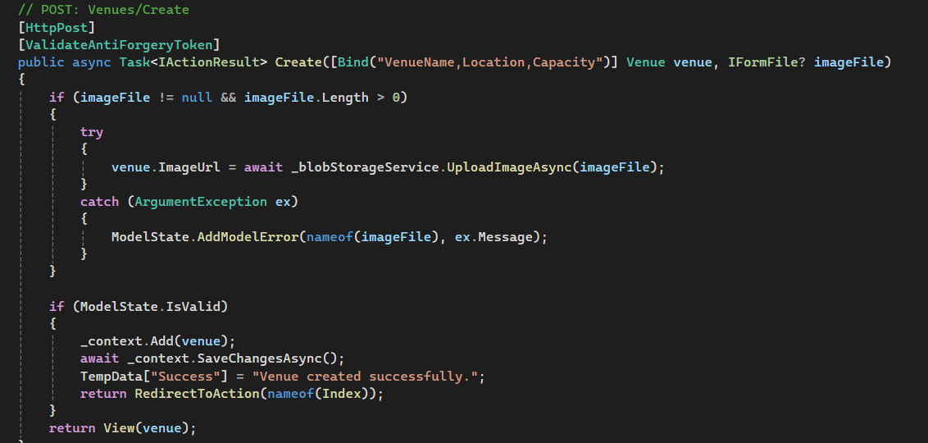
- Implementing Error Handling and Validation.

Validation to prevent the double booking of a venue for two different events on the same date and time.
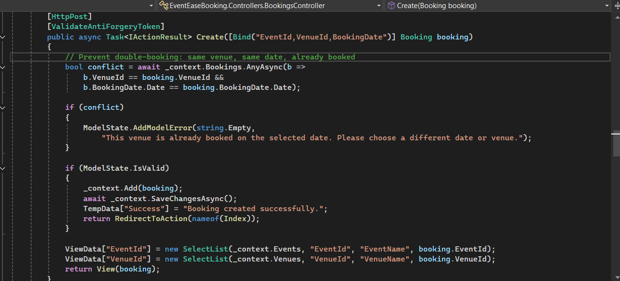

Validation to restrict the deletion of venues or events associated with active bookings.
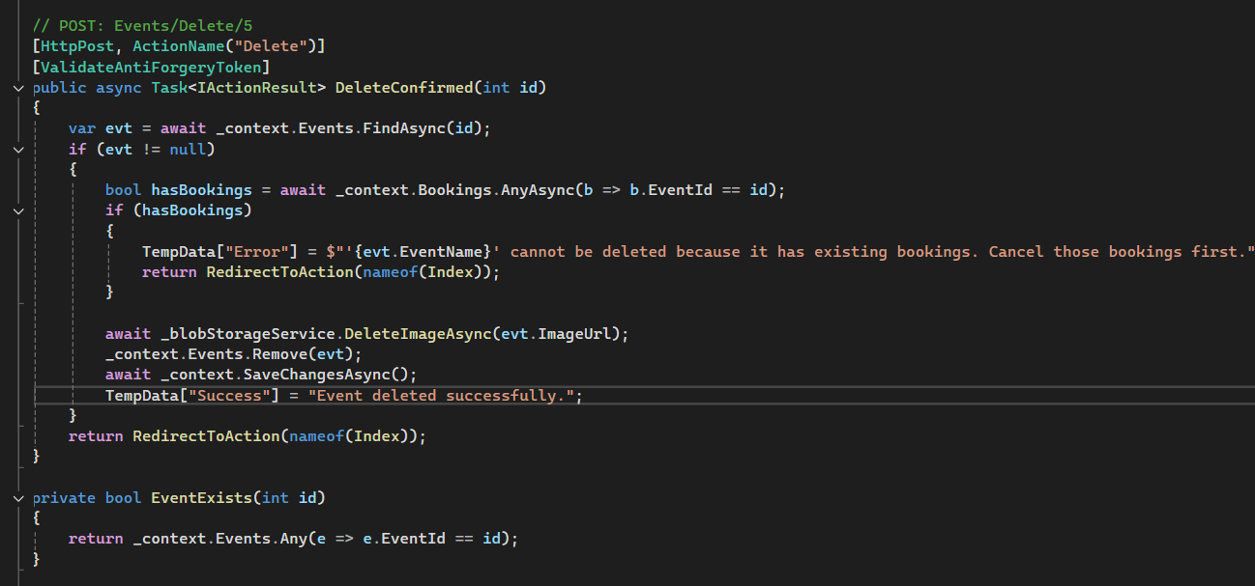

Ensuring the application does not crash on common user error actions, such as a user adding a new venue without a required field.
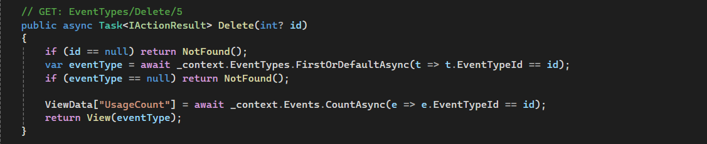
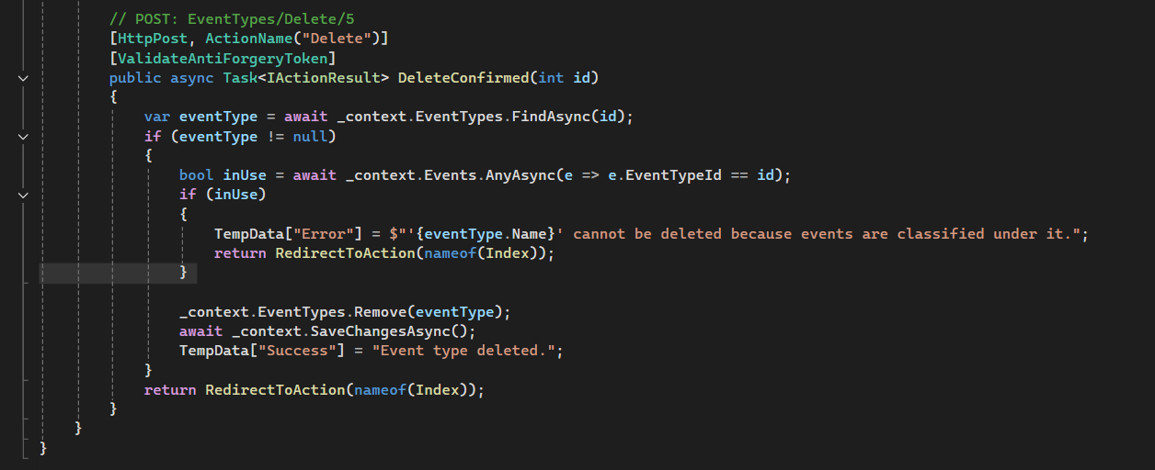

function that displays an alert to the user when a validation error occurs.
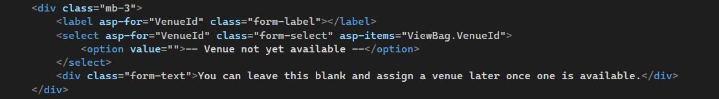
<div class="mb-3">
<label asp-for="VenueId" class="form-label"></label>
<select asp-for="VenueId" class="form-select" asp-items="ViewBag.VenueId">
<option value="">-- Venue not yet available --</option>
</select>
<div class="form-text">You can leave this blank and assign a venue later once one is available.</div>

- Enhanced Display and Search
The view below includes all the relevant information coming from the venue and event tables
and provide relevant booking information.
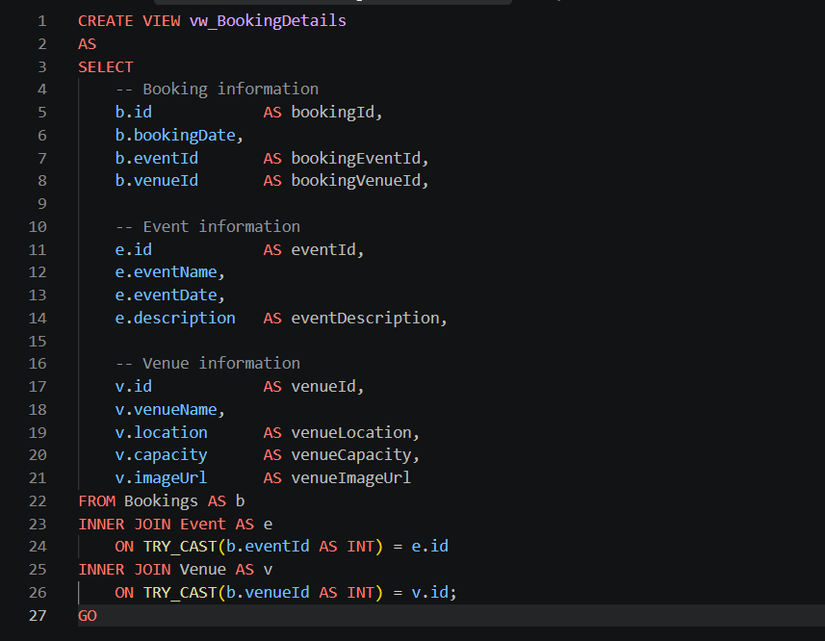
Booking function to allow booking using BookingID or Event Name.
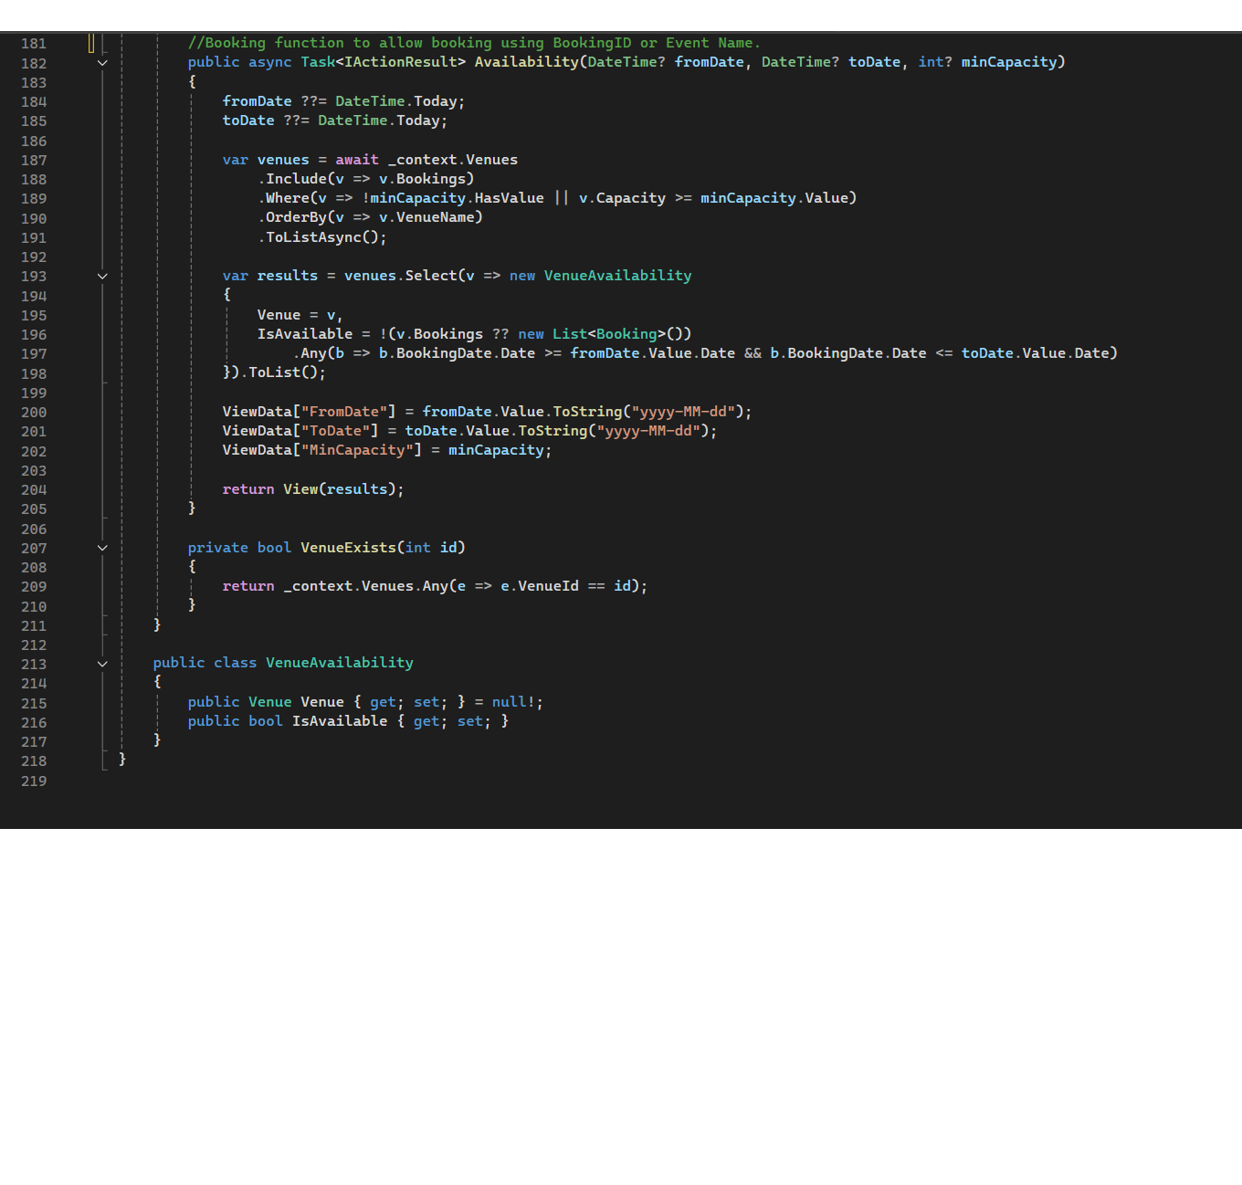

- Azure Deployment Updates.
Deploy the updated web application with Azure storage.
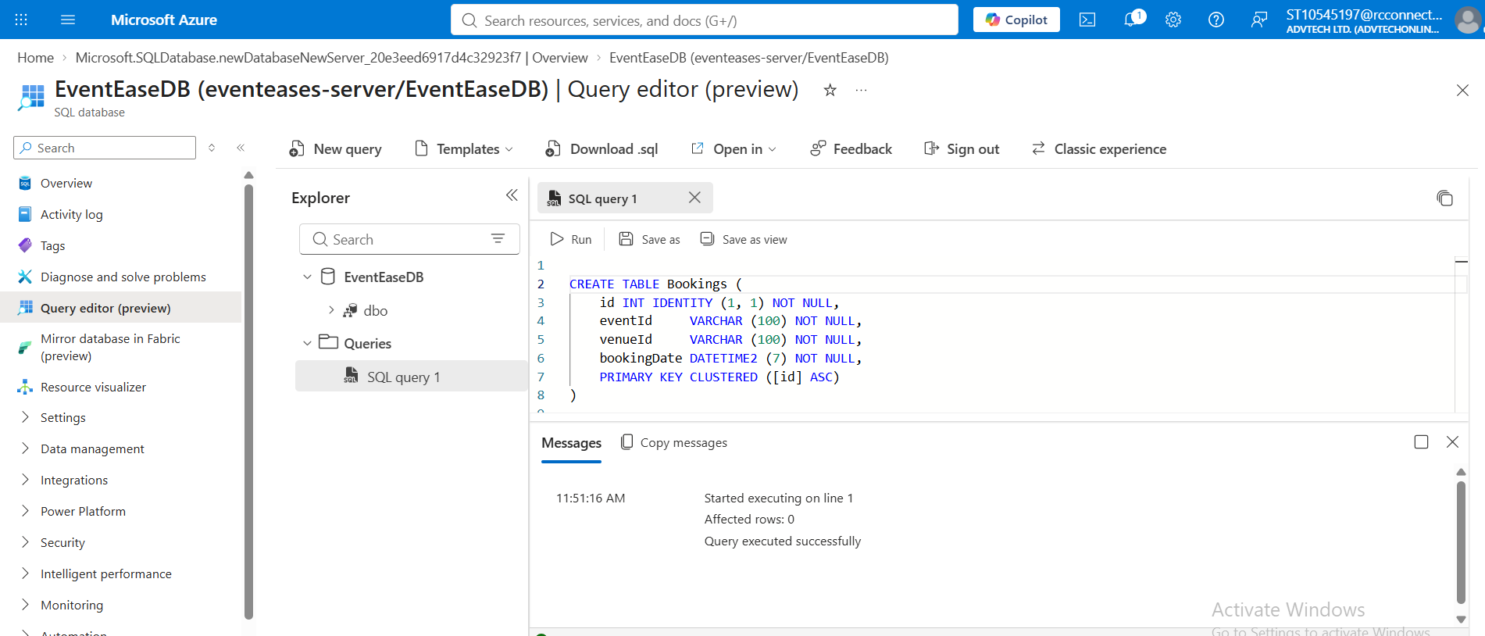
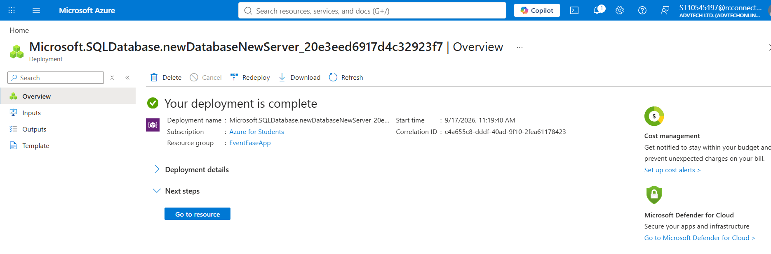
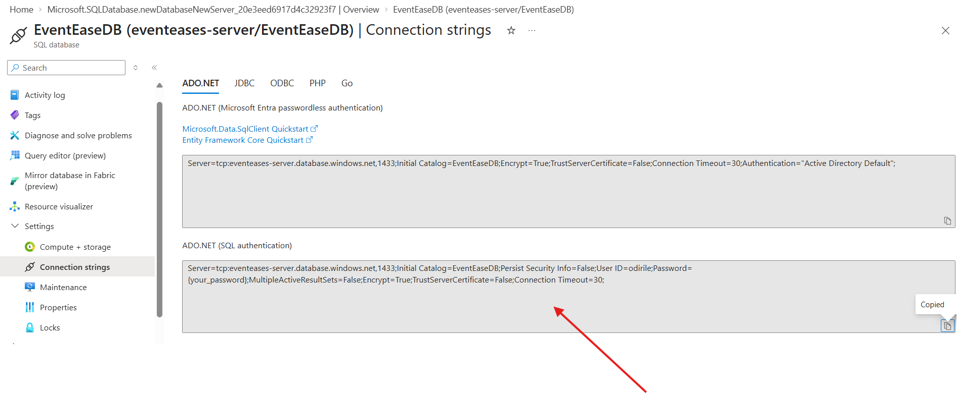

- Database Design, Cognitive Search.
Azure Cognitive Search
How it differs from traditional search
A traditional search engine only matches the exact words you type against the words in a document. Azure Cognitive Search is smarter in three ways:
- It understands meaning, not just words. Searching "car insurance cost" can find "price of vehicle cover."
- It can read more than plain text. It can pull text out of images and scanned PDFs, detect languages, and find names, places, and key phrases.
- It is fully managed. Azure runs and scales it for you, and it has built-in features like filters, autocomplete, and typo tolerance.
Where it has a clear advantage
- Company document search: finding information in thousands of PDFs, contracts, and scans.
- Online shops: filters, spelling-mistake tolerance, and better product results
- Customer support: finding the right help article even when the customer words the problem differently
- Multilingual content: searching across documents in different languages
Limitations and how to fix them
Limitation | Simple fix
It can get expensive | Start with a small plan and only scale up when needed
The search index is a copy, so it can become outdated | Schedule regular updates
It is not a database | Keep your main data in a database and use search only to find things
Changing the index structure is hard | Plan the structure carefully before you build
AI can make mistakes (e.g. poor scans) | Check sample results and fix problem areas
Results may need tuning | Adjust the ranking settings and test with real searches
It only works on Azure | Accept the lock-in or keep your data portable

